

Requirements – Group Insurance by FTE Cash Allocation

Prepared by: Lisa Nordling
March 25th, 2026

Document Control

Change Record
Name | Role | Date | Version | Change Reference
Lisa Nordling | Preparer | 03/25/2026 | V1
Sherry Pellegrini | Reveiwer | 03/30/2026 | V2 | Updates to calculations and JE logic
Lisa Nordling |  | 4/7/2026 | V3 | Updates based on meeting with Jackson and Lauralynn

Reviewers
Name | Role | Date
Sherry Pellegrini | Sr Software Engineer | 03/30/2026
Jackson Okello | Accounting Analyst
Lauralynn Harris | Accounting Manager
Note to Holders:
If you receive an electronic copy of this document and print it out, please write your name on the equivalent of the cover page, for document control purposes.
If you receive a hard copy of this document, please write your name on the front cover, for document control purposes.
Purpose of this document
This document provides the business requirements for the allocation process to spread Group Insurance Cash costs by FTE for the purpose of building a process in EPA (Enterprise Planning Application – an IBM Planning Analytics System).

Contents

1. Introduction 5
a. Background 5
b. Document Scope 5
2. Key Business Decisions 5
3. Control Report 5
4. Data for Cash Group Insurance by FTE 5
5. Allocation Calculation 6
6. New Attributes and Measures 8
7. Journal Entry 8
8. Assumptions 9
9. Open Items 9

Introduction

Background
Currently there is a manual process to move the Cash Amount Class of the Group Insurance cost from the original Center/Entity and into the Centers/Entities based on the FTE and Salary percents. These are the requirements to automate that process using the EPA System (IBM Planning Analytics).

Document Scope
This document focuses on documenting the business requirements for the entry for Cash Group Insurance Allocation by FTE Cost.

Key Business Decisions
The following items are the key decisions made with respect to the journal entry:
- Frequency: Process will run monthly.
- Timing: Generally on the first of the month for the prior month end data, with the exception of months where the FTE post lands on the first. In that case then the run will be pushed out so the data is processed in OFSAA and fed into EPA for the allocation process.

Control Report
Each input would have a validated control in place:
- Cash Group Insurance Cost data would be from the Actuals load which currently already has a validation process (P1EP. BATCHVALIDATION in Automic).
- FTE data would be from the Actuals load which currently already has a validation process (P1EP. BATCHVALIDATION in Automic).
- Salary data based on Pay Code “REGU” would have a new balancing process built to ensure that data loaded correctly from the OFSAA file. Initial testing on the OFSAA file would ensure that the data pull is accurate.

Data for Cash Group Insurance by FTE
Group Insurance data to be allocated (existing in EPA currently):
- Accounting Period = Month/Year
- Amount Class = B000
- Entity: E01300:American Bankers Insurance Company of Florida
- Center: C200593:Group Insurance
- Sub Account – A700018-00:Group Ins - Emp Company Cost
- Date = Current reporting month

Sample of starting data from October 2025: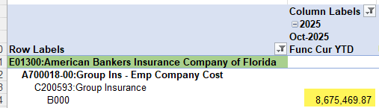

FTE data (existing in EPA currently):
The FTE Data is used to determine the split of the group insurance amount by reporting segment. The FTE data from the Financial Summary cube can be loaded into a Helper cube.
- Version = Actuals
- Location = 1:MANAGERIAL LOCATIONS
- Center = All Centers (except C200591 – will be excluded within EPA and not on OFSAA file)
- Account = A900001-01:Employee FTE Existing
- Entity = E00330 and E01300
- Currency = USD (comes into EPA as QTY)
- Period: Reporting Period YTD

Salary data (new file to be created by OFSAA team):
The Salary Data is used to determine the % of the segment’s cash amount that each Center/Entity (within that segment) will be allocated. This data can be loaded directly into a Helper cube.
- Version = Actuals
- Location = 1:MANAGERIAL LOCATIONS
- Center = All Centers (except C200591 – will be excluded within EPA and not on OFSAA file)
- Account = A700001-01:Salaries – Regular
- Entity = E00330 and E01300
- Amount Class = B000
- Currency = USD
- Pay_Code = REGU
- Journal_Source = ADP_P3
- Created_By = PAYROLL

Allocation Calculation
The build will encompass two different calculation routes in the event that the calculation is simplified no additional coding would be needed. A setting would be put on the Entity E01300 / Center C200593 for either Salary or Rate.
This calculation below will encompass the process for Salary setting (current manual process):
Centers are broken down by Segment (Corporate, Housing and Lifestyle) with the SUM of each of their FTE divided by the starting data amount to get a $ amount of the starting data by Segment. This would be considered the Cash Group Insurance by Segment.
Sample of Cash Group Insurance by Segment for Oct 2025 – Group Insurance 8,675,469.87 / 2,421 FTE Corporate = 2,059,754.10 for Corporate Segment: 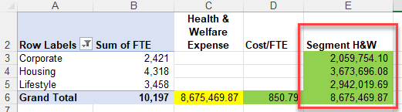
Additionally, each Entity/Center’s Salary data is divided by the total Salaries within their respective Segment to get an individual Rate (%) by Entity/Center combination.
Sample of Individual Rate calculation – 1,676 / 12,106,615 = 0.0138%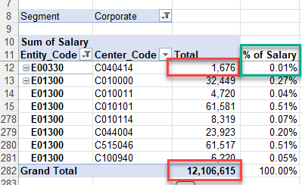
The Rate by Entity/Center/Segment is then multiplied but the Cash Group Insurance by Segment to get the amount allocated to that Entity/Center.
Sample of final Allocation calculation – Corporate Segment Amount $2,059,754.10 x 0.0138% = 285.15 to be allocated to C040414:
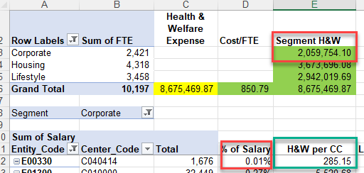

This calculation below will encompass the process for Rate setting (potential future process):
This calculation would take the starting Group Insurance amount and divide it by the total FTE to get a rate per person. No salary data is used in this calculation.

Sample of Rate calculation – Group Insurance Amount $8,675,469.87 / 10,197 Total FTE = 850.79 to determine the rate:
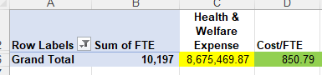

Once the Rate is determined, it will be used to multiply by the FTE per Entity/Center to determine the amount to be allocated to that combination.

Sample of Allocation calculation – Rate of $850.79 x 2 FTE in Entity E01300 / Center C01000 = $1,701.57 to be allocated:
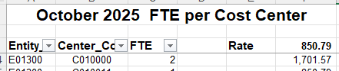

New Attributes and Measures
    - New Center attribute to flag Centers excluded for FTE and Salary data (GrpIns Excl Flag)
    - Build hierarchy based on unflagged items on Center attribute GrpIns Excl Flag (GrpIns Centers)
    - New Center attribute to set Centers’ segment for grouping (Segment)
    - Build hierarchy based on Segment values on Center attribute Segment (Segment Centers)
    - New Entity attribute to flag the Entities that are included for the FTE and Salary data (GrpIns Incl Flag)
    - Build hierarchy based on flagged items on Entity attribute GrpIns Incl Flag (GrpIns Entities)
    - Account attributes: For A700018-00:Group Ins - Emp Company Cost (GrpIns Source) and A900001-01:Employee FTE Existing (GrpIns FTE)
    - New Allocation cube hierarchy: TDB as part of design

Journal Entry
  - Allocate FROM:
    - Entity: Entity (original)
    - Sub-accounts: A700018-00
    - Center: Offset – C200593 (starting data Center) / Allocation – FTE Center from calculation
    - Affiliate = E00000 for Total amount allocated to Entity E01300;
and E00330 for Total amount allocated to Entity E00330
  - Allocate TO:
    - Entity: Entity (based on center/entity combination from calculation)
    - Sub-accounts: A700018-00
    - Center: Center (based on Center/Entity combination from calculation)
    - Affiliate = E00000 for Total amount allocated to Entity E01300;
and E01300 for Total amount allocated to E00330
  - ALL JE Lines:
    - GFS_SOURCE_INTERFACE_SYSTEM_CODE = TBD – need to request from EDM
    - GFS_LEDGER_ID = XXX Functional (based on Entity Currency)
    - GFS_EFFECTIVE_DATE = 15th of reporting month
    - GFS_JOURNAL_SOURCE = EPA_P3
    - GFS_JOURNAL_CATEGORY = SDS Interface
    - GFS_JE_CREATION_DATE = Date process is run
    - GFS_ACTUAL_FLAG = A
    - GFS_AMOUNT_CLASS: B000
    - GFS_SUB_PRODUCT = P0000-000
    - GFS_LOCATION = L0001
    - GFS_FUTURE_1 = 0000
    - GFS_FUTURE_2 = 0000
    - GFS_TRANSACTIONAL_CURRRENCY_CODE = based on Entity Currency
    - GFS_SOURCE_INTERFACE_ID = TBD – need to request from EDM
    - GFS_JOURNAL_BATCH_ID = TBD
    - GFS_HEADER_DESCRIPTION = EPA Spread Group Ins By FTE – CASH
    - GFS_JOURNAL_NAME – TBD
    - GFS_LEDGER_NAME = XXX Functional (based on Entity Currency)
    - GFS_PERIOD_NAME = YYYYMM (based on period data is run for)
    - GFS_ACCRL_RVSL_PDS_AHEAD = (No reversal on Cash)
    - GFS_ACCRL_RVSL_DAY = (No reversal on Cash)

The entry has to be recorded at the following granularity to the sub-ledger.
GFS Field
1 | Entity_Code
2 | Amount_Class_Code
3 | SL_Account_Code
4 | Center_Code
5 | Sub_Product_Code
6 | Location_Code
7 | Affiliate_Code
8 | Functional Currency Code
9 | Posted Functional Amount

Assumptions

Open Items
ID | Item | Open Date | Closed Date | Owner | Comment/Next Step

